2023 Sponsorship Form
__ ACE - $3,000
• Team Admission- 4 players
• 4 Mulligans
• Company banner at event
• Recognition on social media
• Verbal acknowledgment at event
• Company logo on event signage
• Link to website from event webpage
• Logo on all promotional materials

__ Eagle Advocate - $2,500
• 3 players admission
• 2 Mulligans
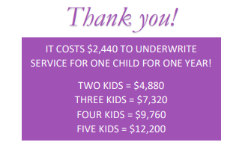
• Verbal acknowledgment at event
• Program insert highlighting business
• Company logo on event signage
• Link to website from event webpage
• Logo on all promotional materials

Event Details:
Saturday, June 22nd
8 am registration 9 am tee off
Captains Choice Scramble
Shotgun Start

Please include how you would like your name to appear on event materials:
___________________________________
Payment Options:
___ Payment is enclosed
___ Please invoice me
___ Paid online at www.bgcolc.org/great-futures-breakfast
Contact Information:
Email Address: _____________________________
Company Name: _____________________________
Company Address: _____________________________
Contact Person: _____________________________
Phone Number: _____________________________
If you are a first-time sponsor, or if your company logo has changed, please
email your logo to oframbes@bgclivingston.org so it can be placed on marketing materials.
Please return form to:
Boys & Girls Club of Livingston County
P.O. Box 311 P.O. Box 71
Pontiac, IL 61764 Fairbury, IL 61739
“Like” us on Facebook
Visit our website at www.bgcolc.org
Thank you for considering sponsoring the Boys & Girls Club
of Livingston County’s Golf Outing!
With Gratitude,

